Deep Learning – Concepts

- Artificial Neural Network (ANN)
- Perceptron
- Single Layer Perceptron
- Multi-Layer Perceptron
- Neurons
- Weights & Bias
- Input, Hidden & Output Layers
- Activation Functions
- Forward Propagation
- Backpropagation
- Loss Functions
- Gradient Descent
- Learning Rate
- Epochs & Batch Size
- Overfitting & Underfitting
- Regularization
- Evaluation Metrics

Perceptron:
- A Perceptron is the simplest type of artificial neural network and the basic building block of deep learning.
- It is a linear binary classifier used for supervised learning.
- The perceptron takes multiple input values, multiplies them with corresponding weights, adds a bias, and applies a step activation function to produce an output of either 0 or 1.
- It works only for linearly separable data and cannot solve complex or non-linear problems.
Single Layer Perceptron (SLP)

- A Single Layer Perceptron (SLP) is the simplest form of an Artificial Neural Network (ANN). It was developed by Frank Rosenblatt in 1958.
- A Single Layer Perceptron is a linear classifier that is used for supervised learning problems involving binary classification, where the output belongs to one of two classes (0 or 1).
- An SLP can be understood as a mathematical model of a biological neuron. It takes multiple input values, processes them using weights and bias, and then decides whether to produce an output (fire) or not.

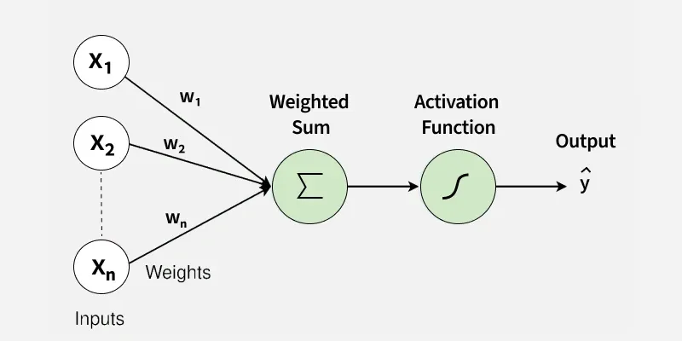

Architecture and Components of SLP
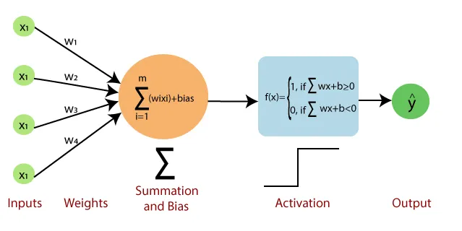
The architecture of a Single Layer Perceptron is very simple. It consists of an input layer directly connected to a single output neuron. There are no hidden layers in an SLP.
Main Components:
1. Inputs $\left(x_{1},x_{2},…,x_{n}\right)$
Inputs are the features or data values given to the model.

2. Weights $\left(w_{1},w_{2},…,w_{n}\right)$
Weights represent the importance or strength of each input. Each input has its own weight.

3. Bias $\left(b\right)$
Bias is an extra parameter added to the model. It helps in shifting the decision boundary, allowing better classification.

4. Summation Function
The perceptron calculates a weighted sum of inputs and bias using the formula:
$$z=\sum_{i=1}^{n}{(}w_{i}x_{i})+b$$

5. Activation Function
A Single Layer Perceptron usually uses a Heaviside Step Function as its activation function.
- If $z≥0$, the output is 1
- If $z<0$, the output is 0
This means the perceptron makes a binary (Yes/No) decision.

- The Single Layer Perceptron works by computing a linear combination of input features using weights and bias.
- Each input value is multiplied by its corresponding weight, and all such products are added together along with a bias term.
- This final value represents the net input to the neuron. The bias plays an important role in adjusting the decision boundary and allows the model to classify data more flexibly.

- After calculating the weighted sum, the perceptron applies an activation function to produce the final output.
- In a Single Layer Perceptron, a step activation function is commonly used. This function compares the weighted sum with a fixed threshold, usually zero.
- If the computed value is greater than or equal to the threshold, the neuron outputs 1; otherwise, it outputs 0. Because of this hard threshold, the SLP always produces a binary output.
Multi-Layer Perceptron (MLP)
- A Multi-Layer Perceptron (MLP) is an artificial neural network that contains more than one layer of neurons.
- Unlike a Single Layer Perceptron, an MLP has one or more hidden layers between the input layer and the output layer.
- Because of these hidden layers, an MLP can learn complex and non-linear patterns.

🔹 Structure of MLP
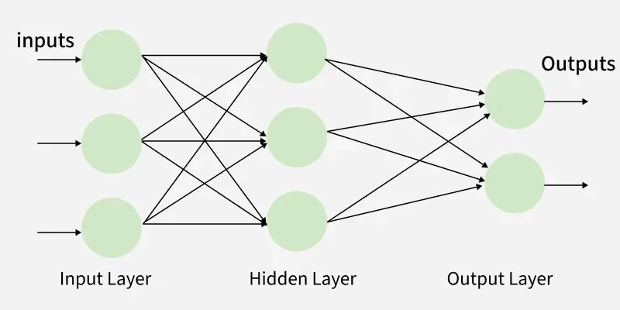

“A Multi-Layer Perceptron is a neural network with one or more hidden layers that uses backpropagation to learn complex patterns.”

MLP consists :
Input Layer – receives the input features
Hidden Layer(s) – performs intermediate computations
Output Layer – produces the final result
Each neuron in one layer is fully connected to neurons in the next layer.

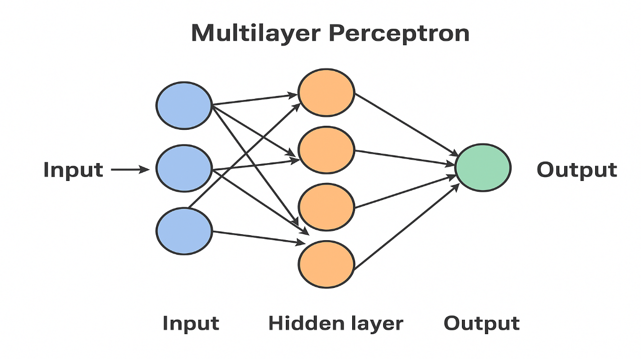
🔹 How MLP Works
Forward Propagation
Input data is passed forward through the network. Each neuron calculates a weighted sum, adds bias, and applies an activation function.

Loss Calculation
The predicted output is compared with the actual output to calculate error (loss).
Backward Propagation
The error is propagated backward, and weights and bias are updated using gradient descent.

🔹 Activation Functions Used in MLP
Sigmoid
Tanh
ReLU
Softmax (output layer)

🔹 Key Features of MLP
Can solve non-linear problems
Uses backpropagation for learning
Works for classification and regression
More powerful than Single Layer Perceptron

🔹 Advantages of MLP
✔ Learns complex relationships
✔ Can solve XOR problem
✔ Flexible and powerful model

Forward propagation
- Forward propagation is the process in a neural network where input data moves forward from the input layer to the output layer to generate a prediction.
- In this process, inputs are multiplied by weights, a bias is added, and an activation function is applied at each neuron to produce the final output.
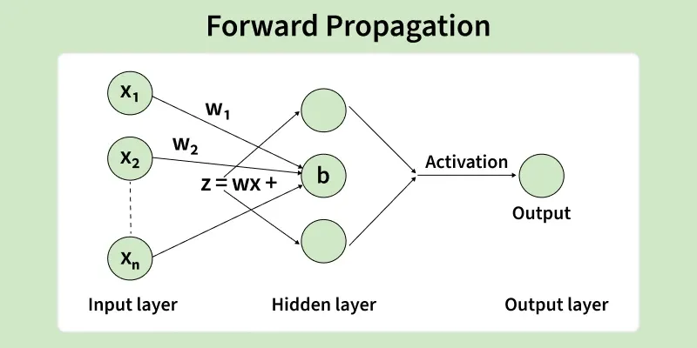
Step-by-Step Forward Propagation
- Input Layer
The input features are given to the network.
- Weighted Sum
Each input is multiplied by its weight and a bias is added:
$$z=w_{1}x_{1}+w_{2}x_{2}+⋯+w_{n}x_{n}+b$$
- Hidden Layers
The output of one layer becomes the input to the next layer.
- Activation Function
The weighted sum is passed through an activation function (ReLU, Sigmoid, etc.).
- Output Layer
The final layer produces the predicted output.

Key Points
- Data moves only in forward direction
- Weights are not updated during forward propagation
- Used to compute prediction

Backward Propagation
Backward propagation (Backpropagation) is the learning process in a neural network where the error is sent backward from the output layer to the input layer to update weights and bias and improve the model’s accuracy.

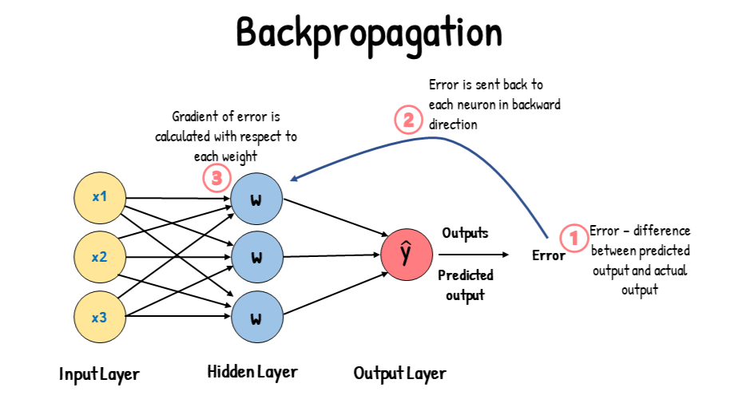

🔹 Step-by-Step Backward Propagation:
- Error Calculation:
The difference between actual output and predicted output is calculated using a loss function.
- Gradient Computation:
The gradient (partial derivative) of the loss with respect to each weight is computed using the chain rule.
- Error Propagation Backward:
The error flows backward from the output layer to hidden layers.
- Weight Update:
Weights and bias are updated using gradient descent:
$$w=w-η\frac{∂L}{∂w}$$
where $η$is the learning rate.
- Repeat Process:
Steps are repeated until the error is minimized.
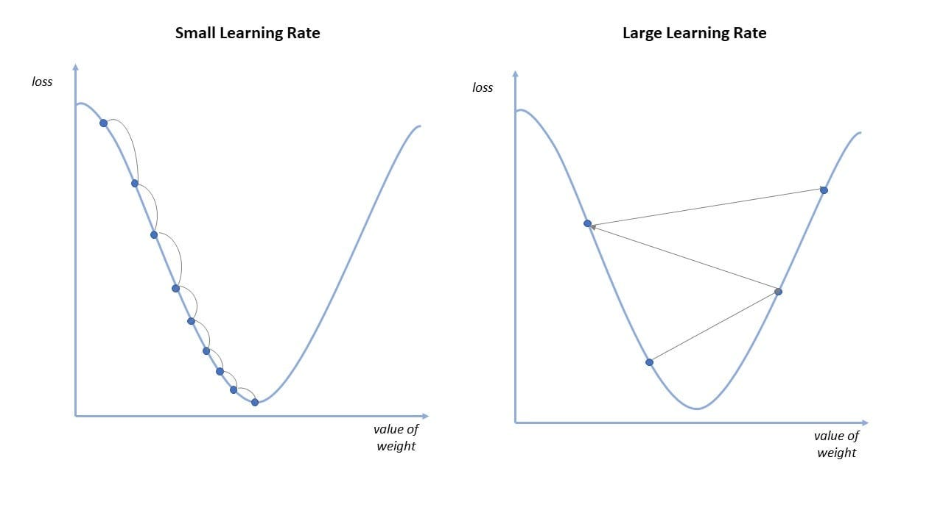
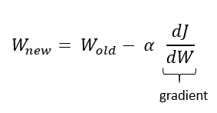
Equation 1. Weights update formula for gradient descent. W = Weights, alpha = Learning rate, J = Cost.

🔹 Key Points
- Works after forward propagation
- Uses gradient descent
- Updates weights and bias
- Makes the model learn from mistakes

